**ACCIDENT DETECTION AND PREVENTION**

**SYSTEM USING ARDUINO**



 **A PROJECT REPORT**

**SUBMITTED BY**

**ANGALA BHARATHI C (Reg No. :923319106004)**

**NITHYA K (Reg No. :923319106025)**

**SANJANA S (Reg No. :923319106038)**

**SOWNDARYA B (Reg No. :923319106045)**

Under the guidance of

**Prof.M.RAJA MADASAMY,M.Tech**

**Assistant prof/ECE**

In partial fulfillment for the award of the degree

of

**BACHELOR OF ENGINEERING**

**IN**

**ELECTRONICS AND COMMUNICATION ENGINEERING**

**GOVERNMENT COLLEGE OF ENGINEERING,BODINAYAKKANUR**

**ANNA UNIVERSITY:CHENNAI 600 025**

**MAY 2023**

**ANNA UNIVERSITY: CHENNAI 600 025**

**BONAFIDE CERTIFICATE**

This is to certify that this project report entitled “**ACCIDENT DETECTION AND PREVENTION SYSTEM USING ARDUINO**” is the bonafide work of **“ANGALA BHARATHI C (Reg. No. : 923319106004), NITHYA K (Reg. No. : 923319106025), SANJANA S (Reg. No. : 923319106038), SOWNDARYA B (Reg. No. : 923319106045)”** who carried out the project work under my supervision.

**SIGNATURE SIGNATURE**

**Dr.V.THIRUNAVUKKARASU, M.E., Ph.D., Prof.M.RAJA MADASAMY ,M.Tech**

**HEAD OF THE DEPARTMENT Assistant Prof/ECE, SUPERVISOR**

Department of Electronics and Department of Electronics and

Communication Engineering, Communication Engineering,

Bodinayakannur – 625 582 Bodinayakannur – 625 582

**Submitted for Anna University project Viva Voice conducted on…………**

**INTERNAL EXAMINER EXTERNAL EXAMINER**

**DECLARATION**

We, hereby jointly declare that the project work titled “**ACCIDENT DETECTION AND PREVENTION AND SYSTEM USING ARDUINO**” submitted to the Anna University Project viva-voice – JUNE 2022 to “**BACHELOR OF ENGINEERING IN ELECTRONICS AND COMMUNICATION ENGINEERING**”, is the report of original project Work done by under the guidance of **Prof.M.RAJA MADASAMY M.Tech,** Department of Electronics and communication Engineering, Government College of Engineering, Bodinayakannur.

NAME SIGNATURE

ANGALA BHARATHI C _________________________

NITHYA K _________________________

SANJANA S _________________________

SOWNDARYA B _________________________

I certify that the declaration made by the above candidates is true.

Project guide,

**Prof.M.RAJA MADASAMY,M.Tech,**

**Assistant Professor/ECE.,**

Department of Electronics and

Communication Engineering,

Bodinayakannur – 625 582.

##### ACKNOWLEDGEMENT

We take this to acknowledge with great pleasure deep satisfaction and convey our gratitude the contribution of many individuals in the successful completion of this project.

We express our profound gratitude **Dr.C.VASANTHANAYAKI,M.E., Ph.D., Government College of Engineering, Bodinayakannur,** for all the support and encouragement given to us throughout our project.

We thank **Dr.V.THIRUNAVUKKARASU,M.E., Ph.D., Head of the Department**, Electronics and Communication Engineering, Government College of Engineering, Bodinayakannur, for his valuable suggestions throughout our project.

We express our gratitude to our guide **Prof.M.RAJAMADASAMY,M.Tech**, Electronics and Communication Engineering, Government College of Engineering, Bodinayakannur, for his guidance and help in doing this project.

Finally, we thank our parents for their financial and moral support and also our friends who helped us in completing our project work successfully.

**LIST OF CONTENTS**

**CHAPTER TITLE PAGE NO**

**ABSTRACT 7**

**I. INTRODUCTION 8**

1. Overview of the project

2. Objective

3. Block diagram

1. **LITERATURE SURVEY 11**
2. **FLOW CHART 12**
3. **ALCOHOL SENSOR 13**

1. Introduction

2. Internal structure of MQ3 alcohol sensor

3. Working

1. **ACCELEROMETER 16**

1. Introduction

2. Working

3. ADXL335 module hardware overview

4. Power and measurement range

1. **GPS MODULE (SIM800L) 18**

1. Working

2. Features

1. **GSM MODULE 21**

1. Introduction

2. Features

1. **TEMPERATURE SENSOR 25**

1. Introduction

2. Working

1. **MICROCONTROLLER 27**

1. Introduction

2. Features

1. **DC MOTOR 31**

1. Introduction

2. Working

1. **FLEX SENSOR 33**

1. Overview

2. Construction

3. Direction to use

**XII. ARDUINO IDE 35**

1. Introduction

2. Working principle

**XIII. RESULT AND DISCUSSION 37**

1. Software requirement

2. Simulation output

**XIV. CONCLUSION 39**

**REFERENCES 41**

**ABSTRACT**

This paper an accident prevention system is being introduced with accident identification for vehicles that will give a higher probability to reduce the accidents taking place every day on roads and at the same time if accident occurs, the system will locate its place and will automatically inform those people who will be able to take immediate actions.

Here, an Arduino based system has been developed by using Global Positioning System (GPS) and Global System for Mobile Communication (GSM) technology.

An accelerometer will also be used that will measure the velocity and the amount of the vehicle’s tilting when it will stuck over something.

When the velocity of the car will be more than the defined maximum velocity for the road or it tilts, a warning will be given automatically.

Also, whenever an accident will take place, the GPS will locate the geographical coordinates for that particular place, and using the GSM it will send an SMS. The system is of low-cost and is user friendly.

**CHAPTER I**

**INTRODUCTION**

1. **OVERVIEW OF THE PROJECT**

In today’s world there is a severe increase in the use of vehicles. Such heavy automobile usage has increased traffic and thus resulting in a rise in road accidents.This takes a toll on the property as well as causes human life loss because of unavailability of immediate preventive and safety facilities. Complete accident prevention is unavoidable but at least repercussions can be reduced. This embedded system can prevent the accident to occur and proper preventive measures are taken in this system.

The ambulance service and the police station can easily find the location as the location along with the google map link was sent to their smart devices with mobile network accessibility. The system consists of flex sensor, temperature sensor, alcohol sensor, accelerometer, GPS module, GSM module,DC motor, buzzer, led etc. and all these devices are interfaced with the central micro controller unit.

We are going to use flex sensor for detecting driver wearing helmet or not,whether driver not wearing the helmet engine will of, we can warn him. Temperature sensor helps us in detecting the heat of the engine and if the engine is overheated then that of a normal condition, we can warn the driver. Alcohol sensor helps us in detecting if the driver is drunk or not. If he/she is over drunk the vehicle provides warning and the engine stops functioning.

Accelerometer detects the occurrence of accident and sends signal to the micro controller for further functioning.GPS module provides us the location, speed, time and date of the certain place where the vehicle is in the real time. If accident occurs, the location of accident that we get from the GPS is send to the ambulance service and police by the help of GSM module. Everything might be all right after a simple accident so the driver can re-inform the ambulance service and police station in this case.

The use of vehicles increases in the proportion of the population. Due to the traffic congestion, the accidents are also increasing day by day. This causes the loss of life due to the delay in the arrival of ambulance to the accident spot or from the accident spot to the hospital. So, it is necessary to take the accident victim to the hospital as soon as possible. Whenever, the accident occurs, it has to be informed to the investigation unit. So, it is also beneficial if the intimation is reached to the enquiry section so that the time for the investigation can be minimized.

**2.OBJECTIVE**

## The main objective of this project is to prevent the accident which happens due to alcoholism of driver, and due to the overheating of engine. Certainly, if the accident happens due to other cases, the used electronic devices will be able to provide the spontaneous message and exact location to police and ambulance in order to recover victims

1. **BLOCK DIAGRAM**

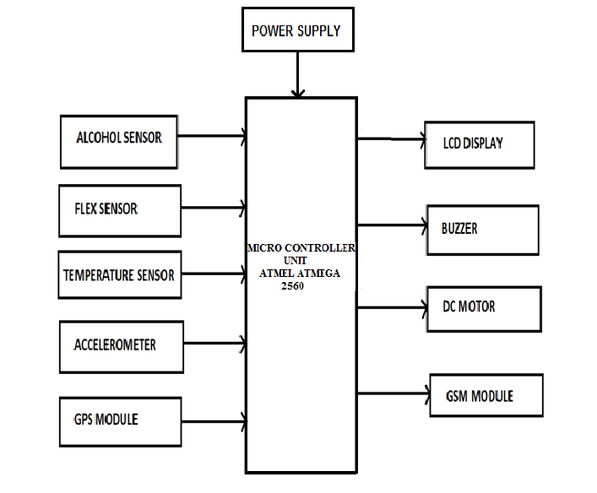

Fig1.1. Block Diagram

**CHAPTER II**

**LITERATURE SURVEY**

The products available in the market are not reliable when it comes to synchronizing more than one parameter. The literature survey revealed that systems available in market has a major disadvantage, it is specifically designed for one sole purpose like Accident detection, Accident prevention or accident reporting.These systems on their own have many advantages but these systems, but from cost point we have to reconsider our decision to buy these products due to their lack of multitasking ability. These systems are useful as it improves their functionalities by adding a feature to the existing system will increase the redundancies.

To overcome this disadvantage, we are proposing a system which could increase the functionality and reliability such that it can prevent the vehicle accident along with accident detection system and accident reporting to the ambulance service and police station.Thus, our proposed system is much more advantageous over the existing system. Sensors are used in everyday objects such as touch-sensitive elevator buttons (tactile sensor) and lamps which dim or brighten by touching the base, besides innumerable applications of which most people are never aware.

With advances in micro machinery and easy-to-use microcontroller platforms, the uses of sensors have expanded beyond the traditional fields of temperature, pressure or flow measurement, for example into MARG sensors. George Atwood invented the very first accelerometer in the 1700s. The Atwood machine, as it was called, consists of masses on springs where the velocity is calculated based on displacements experienced.The Global Positioning System (GPS), originally Navstar GPS, is a satellite-based radionavigation system owned by the United States government and operated by the United States Space Force. The GPS project was started by the U.S. Department of Defense in 1973, with the first prototype spacecraft launched in 1978 and the full constellation of 24 satellites operational in 1993.

The Global System for Mobile Communications (GSM) is a standard developed by the European Telecommunications Standards Institute (ETSI) to describe the protocols for second-generation (2G) digital cellular networks used by mobile devices such as mobile phones and tablets.It was first deployed in Finland in December 1991.By the mid-2010s, it became a global standard for mobile communications achieving over 90% market share, and operating in over 193 countries and territories.

###### CHAPTER III

**1. FLOW CHART**

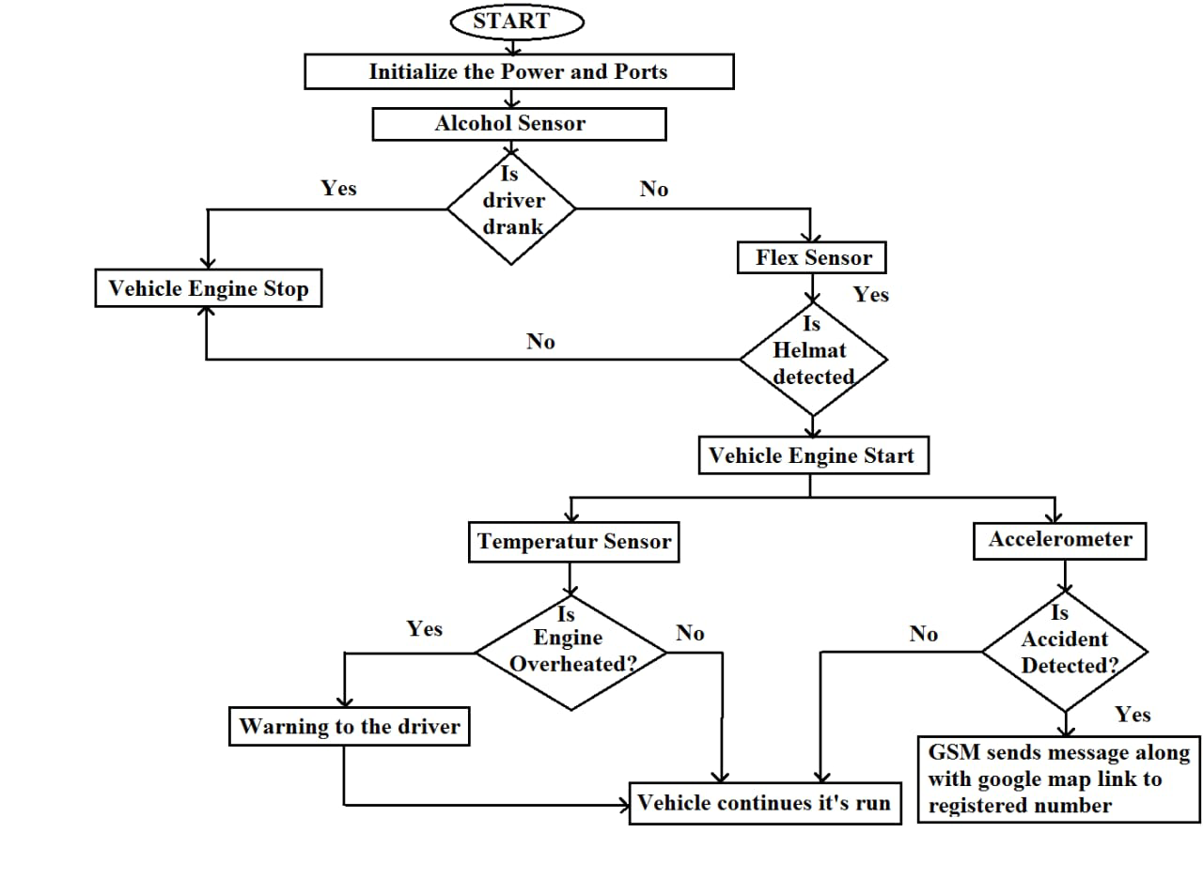

**CHAPTER IV**

## MQ3 Alcohol Sensor

Give your next Arduino project a nose for alcohol by including the MQ3 alcohol sensor module. This sensor detects the presence of alcohol in the air as well as its concentration. So, if you want to build your own breathalyzer to determine how much alcohol is in someone’s breath, the MQ3 alcohol sensor module is an excellent choice.

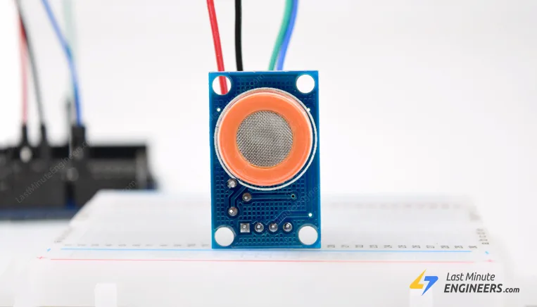

The MQ3 sensor is one of the most widely used in the MQ sensor series. It is a MOS (Metal Oxide Semiconductor) sensor. Metal oxide sensors are also known as **Chemiresistors** because sensing is based on the change in resistance of the sensing material when exposed to alcohol.

The MQ3 alcohol sensor operates on 5V DC and consumes approximately 800mW. It can detect alcohol concentrations ranging from 25 to 500 ppm.

## Internal structure of MQ3 Alcohol Sensor

The MQ3 is a heater-driven sensor. It is therefore covered with two layers of finestainless steel mesh known as an “anti-explosion network”. It ensures that the heater element inside the sensor does not cause an explosion because we are sensing flammable gas (alcohol).

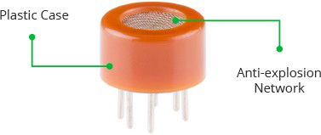

It also protects the sensor and filters out suspended particles, allowing only gaseous elements to pass through the chamber.

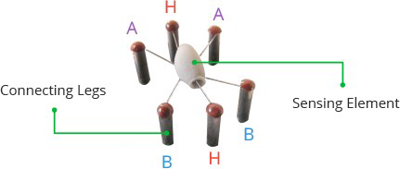,

When the outer mesh is removed, the sensor looks like this. The sensing element and six connecting legs that extend beyond the Bakelite base form the star-shaped structure. Two (H) of the six leads are in charge of heating the sensing element and are linked together by a Nickel- sensor Chromium coil (a well-known conductive alloy).

The remaining four signal-carrying leads (A and B) are connected with platinum wires. These wires are connected to the body of the sensing element and convey slight variations in the current flowing through the sensing element.

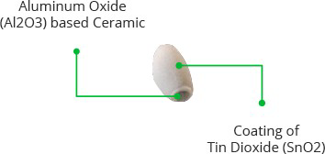

The tubular sensing element is made of Aluminum Oxide (AL2O3) based ceramic with a Tin Dioxide coating (SnO2). Tin Dioxide is the most important material because it is sensitive to alcohol. The ceramic substrate, on the other hand, improves heating efficiency and ensures that the area is continuously heated to the working temperature. 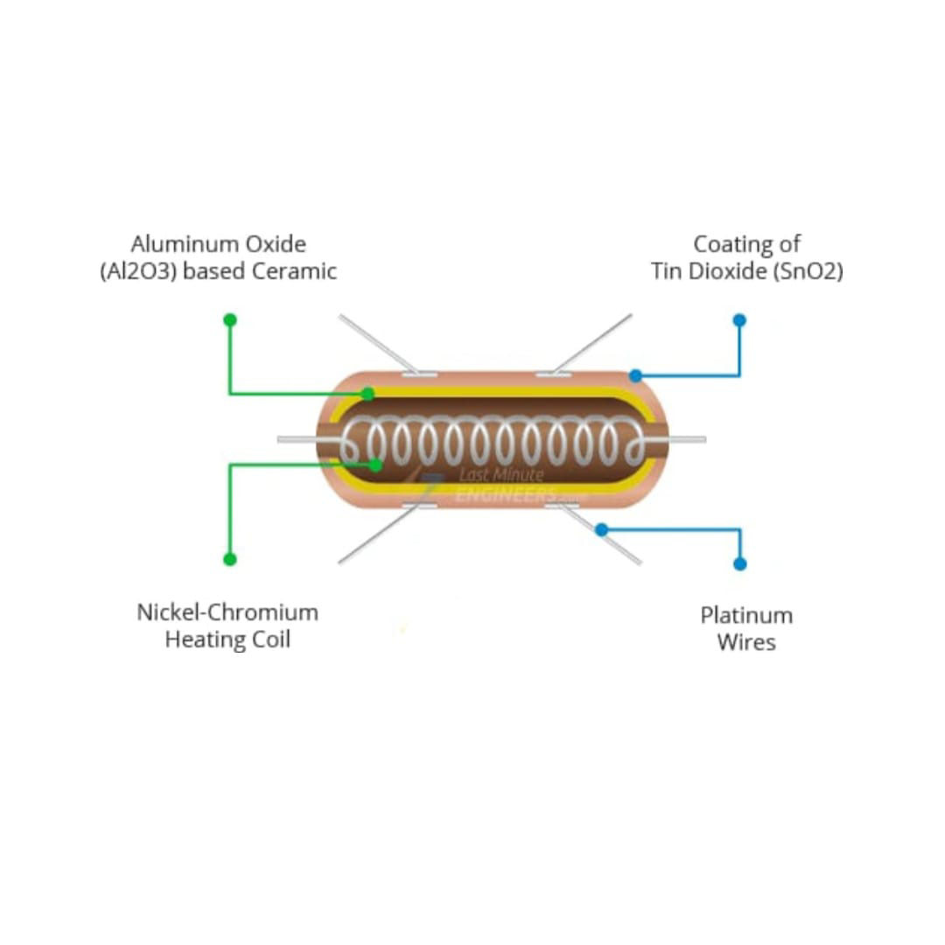

To summarize, the Heating System is composed of a Nickel-Chromium coil and an Aluminum Oxide-based ceramic, while the Sensing System is composed of Platinum wires and a Tin Dioxide coating.

## How Does the MQ3 Alcohol Sensor Work?

When a SnO2 semiconductor layer is heated to a high temperature, oxygen is adsorbed on the surface. When the air is clean, electrons from the conduction band of tin dioxide are attracted to oxygen molecules. This creates an electron depletion layer just beneath the surface of the SnO2 particles, forming a potential barrier. As a result, the SnO2 film becomes highly resistive and prevents electric current flow.

In the presence of alcohol, however, the surface density of adsorbed oxygen decreases as it reacts with the alcohol, lowering the potential barrier. As a result, electrons are released into the tin dioxide, allowing current to freely flow through the sensor.

**CHAPTER V**

**ACCELEROMETER (ADXL 335 MEMS)**

It’s one of the most innovative features of today’s smart phones.

They all have a tiny device called an accelerometer built into the circuitry that detects when you tilt the device from side to side. That’s how your smart phone knows when to switch from portrait to landscape mode. Accelerometer are widely used in low-power, low-cost motion and tilt sensing applications such as mobile devices, gaming systems, disk drive protection, image stabilization, and sports and health devices.

Let’s go over what they are, what they do, and how they work.

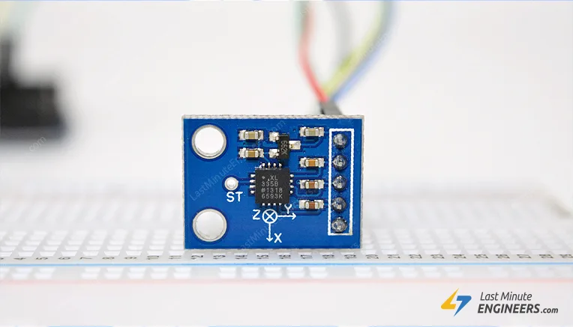

## How Does a MEMS Accelerometer Work?

A MEMS (Micro-Electro-Mechanical System) accelerometer is a micro-machined structure built on top of a silicon wafer. This structure is suspended by polysilicon springs. It allows the structure to deflect when accelerated along the X, Y, and/or Z axes. As a result of deflection, the capacitance between fixed plates and plates attached to the suspended structure changes. This change in capacitance is proportional to the acceleration along that axis.

The sensor processes this change in capacitance and converts it into an analog output voltage.

## ADXL335 Module Hardware Overview

At the core of the module is a small, low-power, low-noise triple axis MEMS accelerometer from [Analog Devices](https://www.analog.com/en/products/adxl335.html) – ADXL335.

It can measure not only static acceleration caused by gravity, but also dynamic acceleration caused by motion, shock, or vibration.

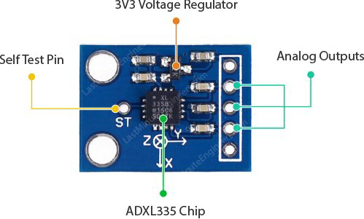

This breadboard-friendly module breaks out every pin of the ADXL335 to a 6-pin, 0.1′′ pitch header, including 3 analog outputs for X, Y, and Z axis measurements, 2 supply pins, and a self-test pin.

### Power

The ADXL335 operates on 1.8V to 3.6VDC (typically 3.3V). However, the on-board 3.3V regulator makes it ideal for interfacing with 5V microcontrollers like the Arduino.

The sensor consumes only 350μA of current during normal operation.

### Measurement Range

The ADXL335 has a full sensing range of ±3g.

Meaning the maximum amount of acceleration that the ADXL335 can accurately measure and represent as an output is ±3g. If it is accelerated at 4g, for example, the accelerometer will not break, but the output may rail.The absolute maximum acceleration of the ADXL335 is 10,000g.

When subjected to accelerations greater than 10,000g, the ADXL335 may fail.

**CHAPTER VI**

**GPS MODULE (NEO-6M)**

Give your next Arduino project the ability to sense locations with the NEO-6M GPS module that can track 22 satellites and identify locations anywhere in the world. It can serve as a great launch pad for anyone looking to get into the world of GPS.

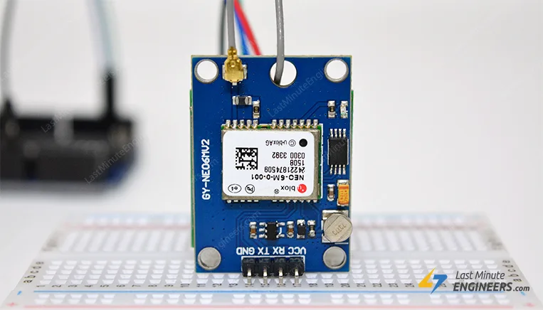

They are low power (suitable for battery operated devices), affordable, easy to interface and extremely popular with hobbyists.

**How does GPS work?**

GPS is a system of 30+ navigation satellites orbiting the earth. We know where they are in space because they constantly transmit information about their position and current time to Earth in the form of radio signals. A GPS receiver listens to these signals. Once the receiver calculates its distance from at least three GPS satellites, it can figure out where you are. This process is known as Trilateration. 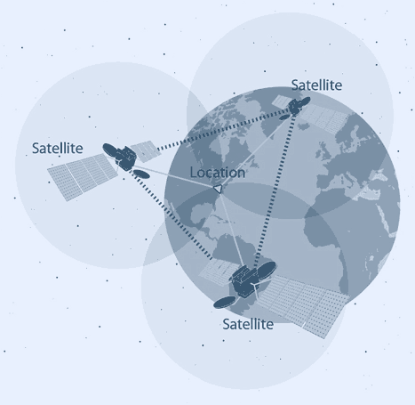

### NEO-6M GPS Chip:

### At the heart of the module is a GPS chip from U-blox – NEO-6M. The chip measures less than a postage stamp but packs a surprising amount of features into its tiny frame.

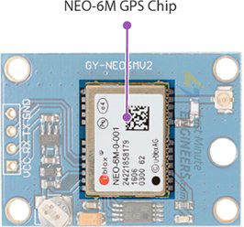

It can track up to 22 satellites over 50 channels and achieve the industry’s highest level of tracking sensitivity i.e. -161 dB, while consuming only 45 mA current. Unlike other GPS modules, it can perform 5 location updates in a second with 2.5m horizontal position accuracy. The U-blox 6 positioning engine also has a Time-To-First-Fix (TTFF) of less than 1 second. One of the best features offered by the chip is Power Save Mode (PSM).

This allows a reduction in system power consumption by selectively switching certain parts of the receiver on and off. This dramatically reduces the power consumption of the module to just 11mA making it suitable for power sensitive applications such as GPS wristwatches.

The required data pins of the NEO-6M GPS chip are broken out to a0.1″pitch headers. It contains the pins needed for communication with the microcontroller over the UART. The module supports baud rates from 4800bps to 230400bps with a default baud of 9600.

**3.3V LDO Regulator**

The operating voltage of the NEO-6M chip ranges from 2.7 to 3.6V. But the good news is, this module comes with MICREL’s [MIC5205](https://www.mouser.com/ds/2/268/mic5205-778789.pdf) Ultra-Low Dropout 3V3 regulator.The logic pins are also 5-volt tolerant, so we can easily connect it to Arduino or any 5V logic microcontroller without using a logic level converter.

### Battery & EEPROM

The module is equipped with HK24C32 Two Wire Serial EEPROM. It is 4KB in size and is connected via I2C to the NEO-6M chip. The module also houses a rechargeable button battery that acts as a super-capacitor.

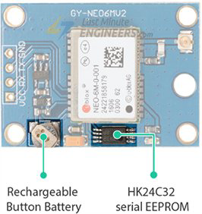

EEPROM and battery together help in retaining the BBR (Battery Backed RAM). BBR contains clock data, latest position data (GNSS orbit data) and module configuration. But it is not for permanent data storage. The battery charges automatically when power is supplied to the module and retains data for two weeks without power. Since the battery retains the clock and last position data, Time-To-First-Fix (TTFF) is significantly reduced to 1s. This allows much faster position locks. Without battery the GPS is always cold-started and takes longer for the initial GPS lock.

**Antenna**

The module comes with -161 dBm sensitivity patch antenna for receiving radio signals from GPS satellites

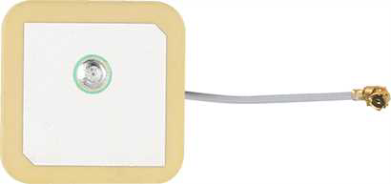

You can snap-fit this antenna into the small U.FL connector located on the module.

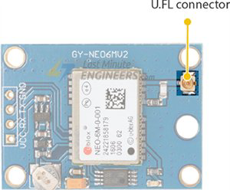

The patch antenna is great for most of our projects. But if you want to get more sensitivity and accuracy, you can also snap- on any 3V active GPS antenna.

**CHAPTER VII**

**GSM MODULE( SIM800L )**

1. **INTRODUCTION**

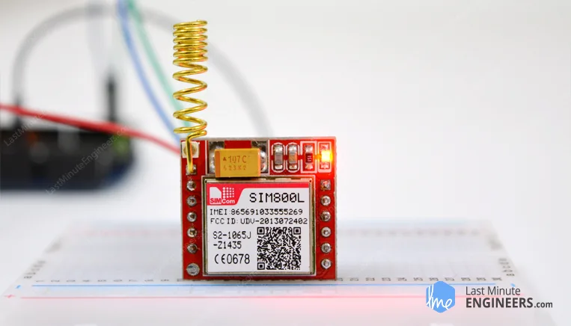

Whether you want to monitor your home from afar or activate the sprinkler system in your garden with a missed call; then the SIM800L GSM/GPRS module can serve as a solid launching point!The SIM800L GSM/GPRS module is a miniature GSM modem that can be used in a variety of IoT projects. You can use this module to do almost anything a normal cell phone can do, such as sending SMS messages, making phone calls, connecting to the Internet via GPRS, and much more.

To top it all off, the module supports quad-band GSM/GPRS networks, which means it will work almost anywhere in the world.

## Hardware Overview

## At the heart of the module is a SIM800L GSM cellular chip from Simcom.The operating voltage of the chip ranges from 3.4V to 4.4V, making it an ideal candidate for direct LiPo battery supply. This makes it excellent choice for embedding in projects with limited space.All the necessary data pins of the SIM800L GSM chip are broken out to a 0.1″ pitch headers, including the pins required for communication with the microcontroller over the UART. The module supports baud rates ranging from 1200 bps to 115200 bps and features automatic baud rate detection.

The module requires an external antenna in order to connect to the network. So the module usually comes with a helical antenna that can be soldered to it. The board also has a U.FL connector If you wish to keep the antenna at a distance from the board.

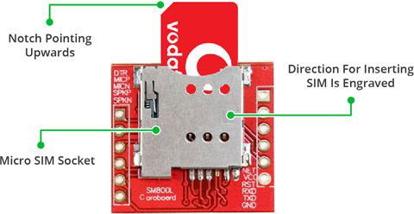

There’s a SIM socket on the back! Any 2G Micro SIM card will work perfectly. The proper way to insert the SIM card is typically engraved on the surface of the SIM socket.

### Features:

### Even though this module is incredibly small—only 1 square inch—it contains a surprising number of features. Some of them are as follows:

* Supports Quad-band: GSM850, EGSM900, DCS1800 and PCS1900
* Connect onto any global GSM network with any 2G SIM
* Make and receive voice calls using an external 8Ω speaker & electret microphone
* Send and receive SMS messages
* Send and receive GPRS data (TCP/IP, HTTP, etc.)
* Scan and receive FM radio broadcasts
* Transmit Power:

Class 4 (2W) for GSM850

Class 1 (1W) for DCS1800

* Serial-based AT Command Set
* FL connectors for cell antennae
* Accepts Micro SIM Card

## Choosing an Antenna:

The SIM800L module requires an external antenna in order to connect to the network, so choosing the right antenna is very important. There are two options available.

The first is a helical antenna that comes with the module and can be soldered directly to the PCB. This antenna is very useful for space-constrained projects. However, be aware that you may face difficulties establishing a connection, particularly if your project is indoors.

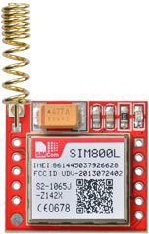

Another option is a 3dBi GSM antenna with a U.FL to SMA adapter, which can be found online for less than $3. You can snap-fit this antenna into the small u.fl connector located on the top-left corner of the module. This type of antenna provides better performance and even allows your module to be placed insidea metal box as long as the antenna is outside.

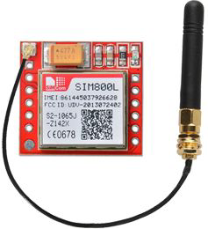

**Power Consumption:**

One of the most important parts of getting the SIM800L module working is supplying it with enough power.The SIM800L, depending on its state, can be a relatively power-hungry device. The module’s maximum current draw is around 2A (especially during a transmission burst). It won’t usually draw that much, but it may need around 216mA during phone calls or 80mA during network transmissions.

This chart from the datasheet summarizes what you can expect:

| Modes | Frequency | Current Consumption |
| --- | --- | --- |
| Power down |  | 60 uA |
| Sleep mode |  | 1 mA |
| Stand by |  | 18 mA |
| Call | GSM850 | 199 mA |
| EGSM900 | 216 Ma |
| DCS1800 | 146 mA |
| PCS1900 | 131 mA |
| GPRS |  | 453 mA |
| Transmission Burst |  | 2 A |

###### CHAPTER VIII

**TEMPERATURE SENSOR(LM35)**

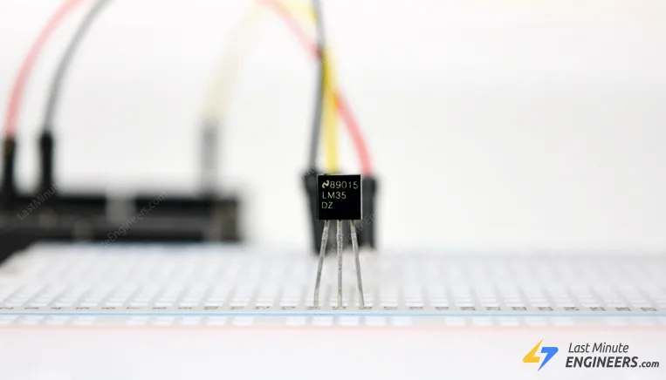

One of the easiest and inexpensive ways to add temperature sensing in your Arduino project is to use LM35 Temperature Sensor. These sensors are fairly precise and needs no external components to work. So, with just a few connections and some Arduino code you’ll be sensing temperature in no time!

## LM35 Temperature Sensor

The LM35 is a low voltage, precision centigrade temperature sensor manufactured by Texas Instruments. It is a chip that provides a voltage output that is linearly proportional to the temperature in °C and is, therefore, very easy to use with an Arduino.

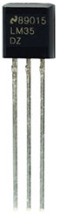

The LM35 temperature sensor is fairly precise, never wears out, works under many environmental conditions and requires no external components to work. In addition, the LM35 sensor does not require calibration and provides a typical accuracy of ±0.5°C at room temperature and ±1°C over a full −55°C to +155°C temperature range.

The sensor can be powered with a 4V to 30V power supply and consumes less than 60µA during active temperature conversions, providing very low self-heating (less than 0.08°C in still air). The only disadvantage of the LM35 sensor is that it requires a negative bias voltage to measure negative temperature.

So if you are planning to use the sensor to measure negative temperature, it is recommended that you use TMP36 temperature sensor. The TMP36 by Analog Devices is fairly accurate (-40°C to 125°C) and has the advantage of being able to measure negative temperatures without the need for negative bias voltage. You can find a dedicated tutorial for the TMP36 below.

A better alternative to the LM35 is to use a digital temperature sensor like the DS18B20 which comes in the same package. Digital temperature sensors have better noise immunity which is useful when the sensor is placed at a distance or in an electrically noisy environment.

## Working Principle

The LM35 uses a solid-state technique to measure the temperature.

It makes use of the fact that the voltage drop between the base and emitter (forward voltage – Vbe) of the [Diode-connected transistor](https://en.wikipedia.org/wiki/Diode-connected_transistor) decreases at a known rate as the temperature increases.

By precisely amplifying this voltage change, it is easy to generate an analog signal that is directly proportional to temperature.

**CHAPTER IX**

**MICROCONTROLLER (ARDUINO MEGA 2560)**

The **Arduino Mega 2560** is a microcontroller board based on the [ATmega2560](http://ww1.microchip.com/downloads/en/DeviceDoc/Atmel-2549-8-bit-AVR-Microcontroller-ATmega640-1280-1281-2560-2561_datasheet.pdf). It has 54 digital input/output pins (of which 15 can be used as PWM outputs), 16 analog inputs, 4 UARTs (hardware serial ports), a 16 MHz crystal oscillator, a USB connection, a power jack, an ICSP header, and a reset button. It contains everything needed to support the microcontroller; simply connect it to a computer with a USB cable or power it with a AC-to-DC adapter or battery to get started. The Mega 2560 board is compatible with most shields designed for the Uno and the former boards Duemilanove or Diecimila.

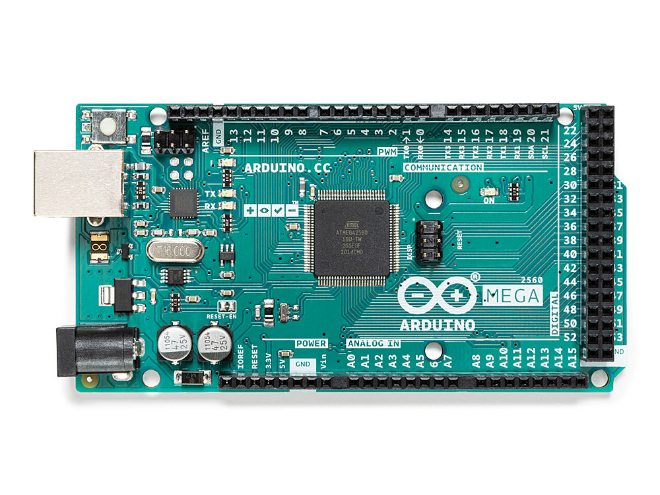

The Mega 2560 is an update to the [Arduino Mega](https://docs.arduino.cc/retired/other/arduino-older-boards#arduino-mega), which it replaces.Related Boards

If you are looking at upgrading from previous Arduino designs, or if you are just interested in boards with similar functionality, at Arduino you can find:

* [**Uno Rev 3**](https://store.arduino.cc/products/arduino-uno-rev3)
* [**Arduino Nano**](https://store.arduino.cc/products/arduino-nano)
* [**Arduino DUE without headers**](https://store.arduino.cc/products/arduino-due-without-headers)

## Tech specs

| Microcontroller | [ATmega2560](http://www.atmel.com/Images/Atmel-2549-8-bit-AVR-Microcontroller-ATmega640-1280-1281-2560-2561_datasheet.pdf) |
| --- | --- |
| Operating Voltage | 5V |
| InputVoltage (recommended) | 7-12V |
| Input Voltage (limit) | 6-20V |
| Digital I/O Pins | 54 (of which 15 provide PWM output) |
| Analog Input Pins | 16 |
| DC Current per I/O Pin | 20 Ma |
| DC Current for 3.3V Pin | 50 Ma |
| Flash Memory | 256 KB of which 8 KB used by bootloader |
| SRAM | 8 KB |
| EEPROM | 4 KB |
| Clock Speed | 16 MHz |
| LED_BUILTIN | 13 |
| Length | 101.52 mm |
| Width | 53.3 mm |
| Weight | 37 g |

### Programming

The Mega 2560 board can be programmed with the [Arduino Software (IDE)](https://www.arduino.cc/en/Main/Software). The ATmega2560 on the Mega 2560 comes preprogrammed with a [bootloader](https://www.arduino.cc/en/Hacking/Bootloader?from=Tutorial.Bootloader) that allows you to upload new code to it without the use of an external hardware programmer. It communicates using the original STK500 protocol ([reference](http://www.atmel.com/Images/doc2525.pdf), [C header files](http://www.atmel.com/dyn/resources/prod_documents/avr061.zip)).

You can also bypass the bootloader and program the microcontroller through the ICSP (In-Circuit Serial Programming) header using [Arduino ISP](https://www.arduino.cc/en/Main/ArduinoISP) or similar; see these [instructions for details](https://www.arduino.cc/en/Hacking/Programmer).

The power pins are as follows:

* Vin. The input voltage to the board when it's using an external power source (as opposed to 5 volts from the USB connection or other regulated power source). You can supply voltage through this pin, or, if supplying voltage via the power jack, access it through this pin.
* 5V. This pin outputs a regulated 5V from the regulator on the board. The board can be supplied with power either from the DC power jack (7 - 12V), the USB connector (5V), or the VIN pin of the board (7-12V). Supplying voltage via the 5V or 3.3V pins bypasses the regulator, and can damage your board. We don't advise it.
* 3V3. A 3.3 volt supply generated by the on-board regulator. Maximum current draw is 50 mA.
* GND. Ground pins.
* IOREF. This pin on the board provides the voltage reference with which the microcontroller operates. A properly configured shield can read the IOREF pin voltage and select the appropriate power source or enable voltage translators on the outputs for working with the 5V or 3.3V.

### Memory

The ATmega2560 has 256 KB of flash memory for storing code (of which 8 KB is used for the bootloader), 8 KB of SRAM and 4 KB of EEPROM (which can be read and written with the [EEPROM library](https://www.arduino.cc/en/Reference/EEPROM)).

### Input and Output

See the mapping between Arduino pins and Atmega2560 ports:

Each of the 54 digital pins on the Mega can be used as an input or output, using [pinMode()](https://www.arduino.cc/en/Reference/PinMode),[digitalWrite()](https://www.arduino.cc/en/Reference/DigitalWrite), and [digitalRead()](https://www.arduino.cc/en/Reference/DigitalRead) functions. They operate at 5 volts. Each pin can provide or receive 20 mA as recommended operating condition and has an internal pull-up resistor (disconnected by default) of 20-50 k ohm. A maximum of 40mA is the value that must not be exceeded to avoid permanent damage to the microcontroller.

In addition, some pins have specialized functions:

* Serial: 0 (RX) and 1 (TX); Serial 1: 19 (RX) and 18 (TX); Serial 2: 17 (RX) and 16 (TX); Serial 3: 15 (RX) and 14 (TX). Used to receive (RX) and transmit (TX) TTL serial data. Pins 0 and 1 are also connected to the corresponding pins of the ATmega16U2 USB-to-TTL Serial chip.
* External Interrupts: 2 (interrupt 0), 3 (interrupt 1), 18 (interrupt 5), 19 (interrupt 4), 20 (interrupt 3), and 21 (interrupt 2). These pins can be configured to trigger an interrupt on a low level, a rising or falling edge, or a change in level. See the [attachInterrupt()](https://www.arduino.cc/en/Reference/AttachInterrupt) function for details.
* PWM: 2 to 13 and 44 to 46. Provide 8-bit PWM output with the [analogWrite()](https://www.arduino.cc/en/Reference/AnalogWrite) function.
* SPI: 50 (MISO), 51 (MOSI), 52 (SCK), 53 (SS). These pins support SPI communication using the[SPI library](https://www.arduino.cc/en/Reference/SPI). The SPI pins are also broken out on the ICSP header, which is physically compatible with the Arduino /Genuino Uno and the old Duemilanove and Diecimila Arduino boards.
* LED: 13. There is a built-in LED connected to digital pin 13. When the pin is HIGH value, the LED is on, when the pin is LOW, it's off.
* TWI: 20 (SDA) and 21 (SCL). Support TWI communication using the [Wire library](https://www.arduino.cc/en/Reference/Wire). Note that these pins are not in the same location as the TWI pins on the old Duemilanove or Diecimila Arduino boards.

See also the mapping Arduino Mega 2560 PIN diagram.

The Mega 2560 has 16 analog inputs, each of which provide 10 bits of resolution (i.e. 1024 different values). By default they measure from ground to 5 volts, though is it possible to change the upper end of their range using the AREF pin and [analogReference()](https://www.arduino.cc/en/Reference/AnalogReference) function.  
There are a couple of other pins on the board:

* AREF. Reference voltage for the analog inputs. Used with analogReference().
* Reset. Bring this line LOW to reset the microcontroller. Typically used to add a reset button to shields which block the one on the board.

**CHAPTER X**

**DC.MOTOR**

## Working Principle of DC Motor

DC motor is an electrical machine which converts electrical energy into mechanical energy. The basic working principle of the DC motor is that whenever a current carrying conductor places in the magnetic field, it experiences a mechanical force.

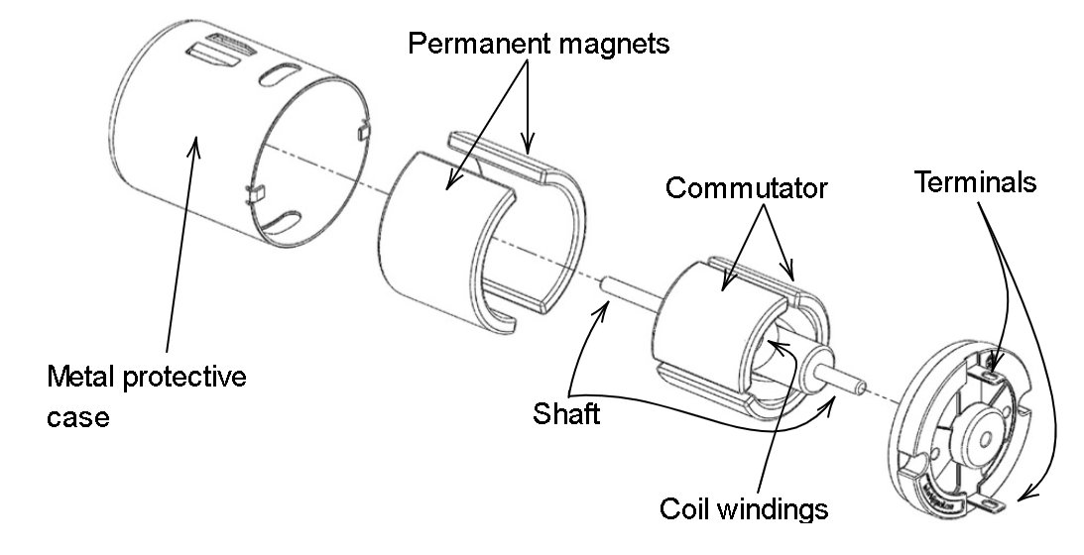

Fleming's left-hand rule and its magnitude decide the direction of this force.

**Fleming's Left Hand Rule**:

If we stretch the first finger, second finger and thumb of our left hand to be perpendicular to each other, and first finger represents the direction of the magnetic field, the second finger represents the direction of the current, then the thumb represents the directiSon of the force experienced by the current carrying conductor.

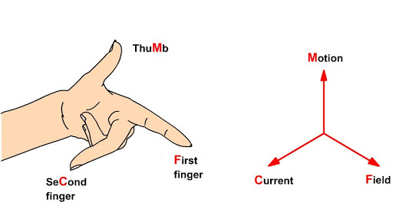

**F = BIL Newtons**

Where,

B = magnetic flux density,

I = current and

L = length of the conductor within the magnetic field.

When armature winding is connected to a DC supply, an electric current sets up in the winding.  Permanent magnets or field winding (electromagnetism) provides the magnetic field. In this case, current carrying armature conductors experience a force due to the magnetic field, according to the principle stated above.

The [Commutator](https://www.google.com/search?q=commutator&rlz=1C1AVFA_enIN801IN801&oq=commutator&aqs=chrome..69i57j0l7.2814j0j7&sourceid=chrome&ie=UTF-8) is made segmented to achieve unidirectional torque. Otherwise, the direction of force would have reversed every time when the direction of movement of the conductor is reversed in the magnetic field. This is how a DC motor works!

## Back- EMF of DC motor

According to the fundamental law of nature, no energy conversion is possible until there is something to oppose the conversion. In case of generators, magnetic drag provides this opposition, but in the case of dc motors, there is back emf. Presence of the back emf makes a dc motor ‘self-regulating’.When the armature of a motor is rotating, the conductors are also cutting the magnetic flux lines and hence according to the[Faraday's law of electromagnetic induction](https://www.electrical4u.com/faraday-law-of-electromagnetic-induction/), an emf induces in the armature conductors.

The direction of this induced emf is such that it opposes the armature current (Ia). The circuit diagram below illustrates the direction of the back emf and armature current.

### Significance of Back-EMF

Magnitude of back emf is directly proportional to speed of the motor. Consider the load on a dc motor is suddenly reduced. In this case, required torque will be small as compared to the current torque. Speed of the motor will start increasing due to the excess torque. Hence, being proportional to the speed, magnitude of the back emf will also increase. With increasing back emf armature current will start decreasing. Torque being proportional to the armature current, it will also decrease until it becomes sufficient for the load. Thus, speed of the motor will regulate.

On the other hand, if a dc motor is suddenly loaded, the load will cause decrease in the speed. Due to decrease in speed, back emf will also decrease which allows more armature current. Due to increase in armature current  the torque will increase to fulfill the load requirement.

**CHAPTER XI**

**FLEX SENSOR (2.2”)**

A flex sensor, also known as a bend sensor, is a low-cost, simple-to-use sensor used to measure the amount of deflection or bending.It gained popularity in the 1990s due to its inclusion in the Nintendo Power Glove. People have been using it ever since as a goniometer to measure joint movement, a door sensor, a bumper switch to detect walls, and a pressure sensor on robotic grippers.

## Flex Sensor Overview:

A flex sensor is basically a variable resistor, whose resistance varies when bent. Because the resistance is directly proportional to the amount of bending, it is often referred to as a Flexible Potentiometer.Flex sensors are typically available in two sizes: 2.2′′ (5.588cm) long and 4.5′′ (11.43cm) long.

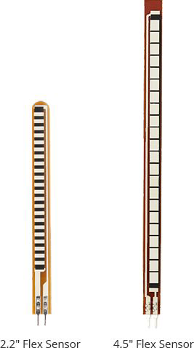

### Construction

A conductive ink based flex sensor is made of a phenolic resin substrate onto which conductive ink is applied. A segmented conductor is then placed on top to create a flexible potentiometer.

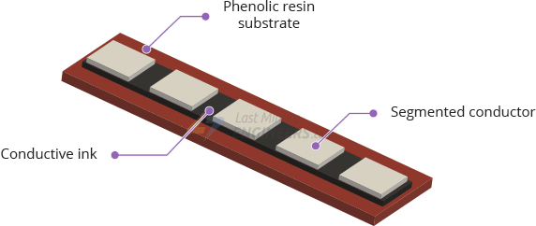

### Directions to Use

The flex sensor is only designed to be flexed in one direction, away from the ink, as shown in the image below. If you bend the sensor in the opposite direction, you will not receive accurate data and you may even damage it.

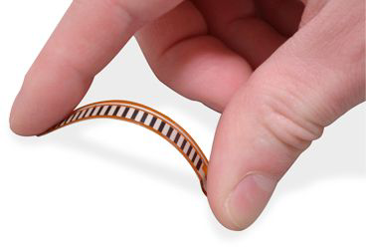

Also, avoid bending the sensor too close to the base (where the pins are crimped), as this can cause it to kink and fail.

## How Do Flex Sensors Work?

The conductive ink on the sensor serves as a resistor. When the sensor is straight, this resistance is around 25k.

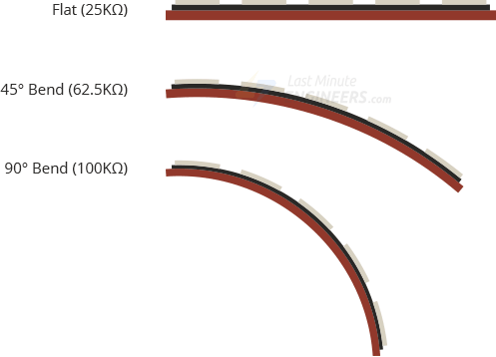

When the sensor is bent, the conductive layer is stretched, resulting in a reduced cross section (imagine stretching a rubber band) and increased resistance. At a 90° angle, this resistance is approximately 100K.When the sensor is straightened out again, the resistance returns to its original value. By measuring the resistance, you can determine how much the sensor is bent.

**CHAPTER XII**

**ARDUINO IDE:**

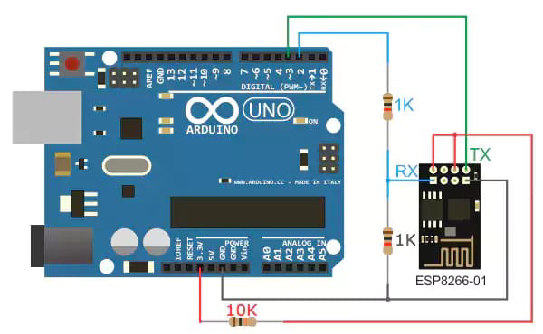

**Arduino IDE working Principle:-**

The Arduino Integrated Development Environment - or Arduino Software (IDE) - contains a text editor for writing code, a message area, a text console, a toolbar with buttons for common functions and a series of menus.

It connects to the Arduino hardware to upload programs and communicate with them.

**How ARDUINO IDE works:**

The Arduino is a board based on an ATMEL AVR microcontroller. Microcontrollers are integrated circuits where instructions can be recorded, which you write with the programming language that you can use in the Arduino IDE environment.

These instructions allow you to create programs that interact with the circuitry on the board.

The most used microcontrollers on Arduino platforms are the Atmega168, Atmega328, Atmega1280, ATmega8 for their simplicity, but it is being expanded to Atmel microcontrollers with 32-bit ARM architecture and also to Intel microcontrollers.

The Arduino microcontroller has communication ports and input / output ports. with which we can connect different types of peripherals on the board.

The information of these peripherals that you connect will be transferred to the microcontroller, which will be in charge of processing the data that comes through them.

On the other hand, Arduino provides us with software consisting of a development environment (IDE) that implements the Arduino programming language, the tools to transfer the firmware to the microcontroller and the bootloader executed on the board.

The main feature of the software and the programming language is its simplicity and ease of use.

**CHAPTER XIII**

**RESULT AND DISCUSSION**

**1. SOFTWARE REQUIREMENT**

Use the Arduino IDE on your computer to create, open, and change sketches (Arduino calls programs “Sketches”).

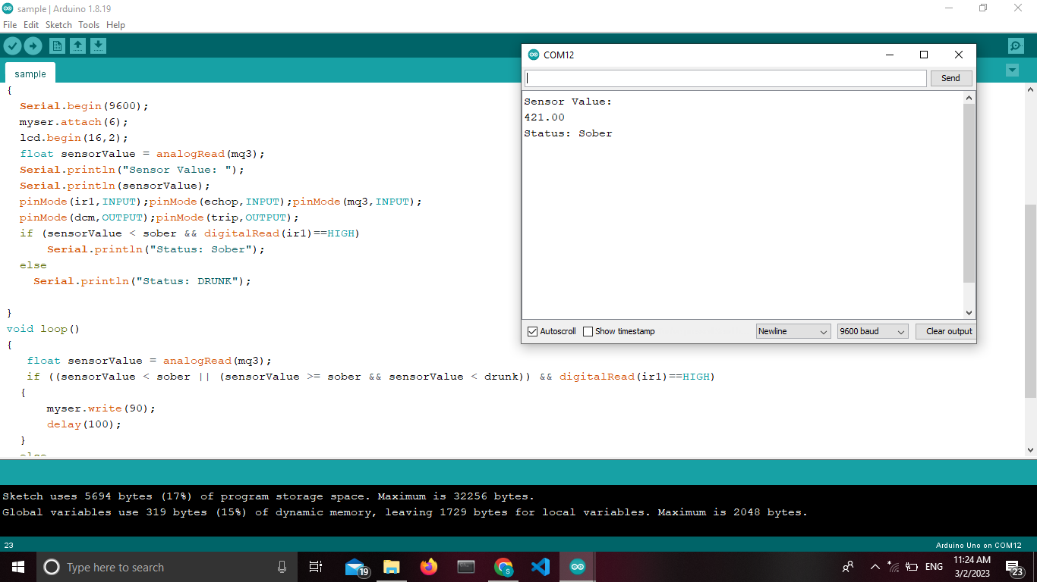

**2.SIMULATION OUTPUT:**

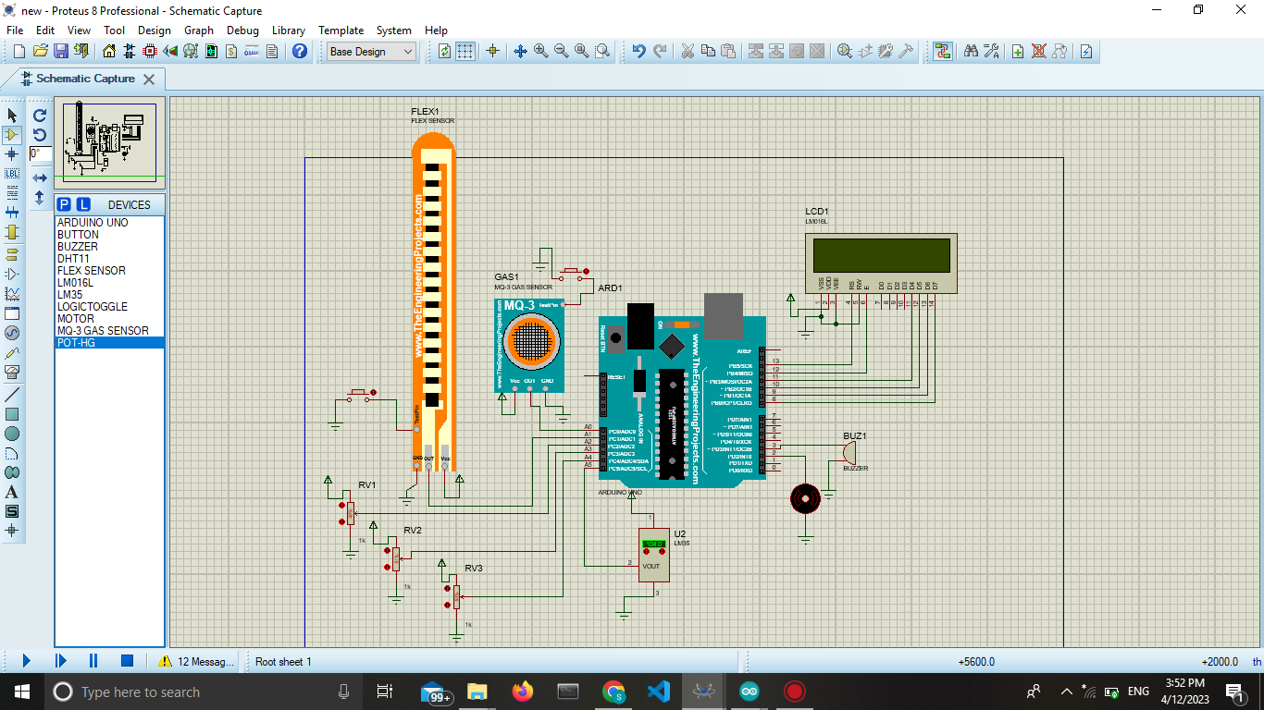

**SYSTEM OUTPUT:**

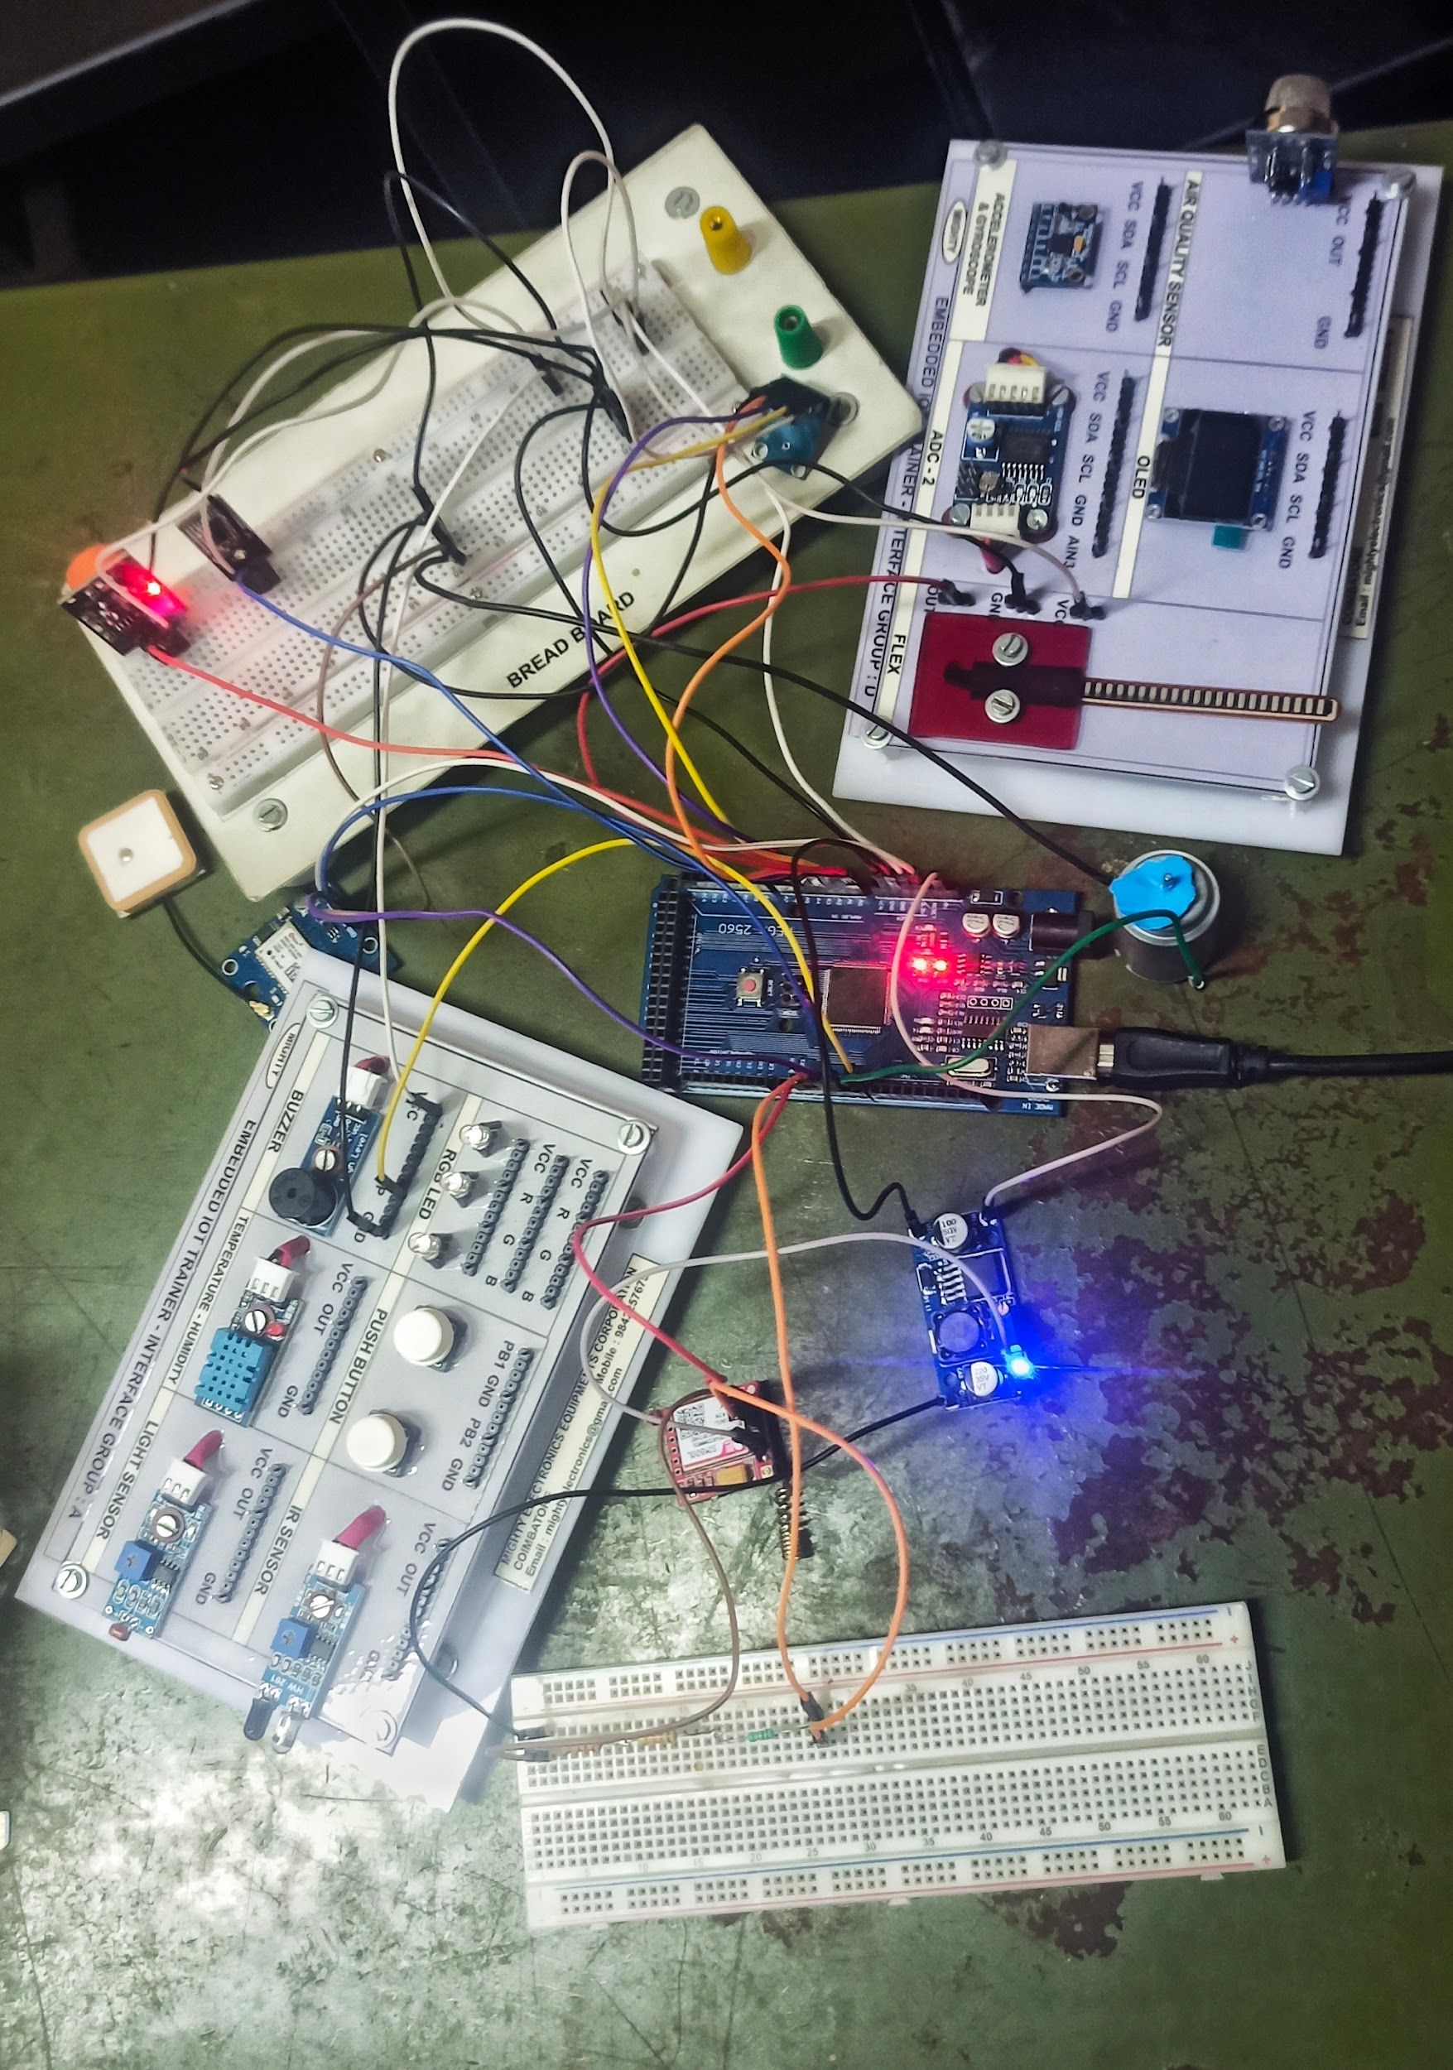

**CHAPTER XIV**

**CONCLUSION**

The Vehicle Accident Prevention, Detecting and Reporting System could be a safer system, saving approximately two-thirds of the lives lost in dangerous road accidents, particularly in remote areas with low human activity. The GPS tracker attached to the system gives information about the exact geographical location that could specify the latitude and longitude. The SMS alert is immediately sent to nearby hospitals, ambulances, and police stations, as well as the victim's family members.

The ambulance could arrive at the accident spot immediately by using the location details and quick medical help could be provided to the victim involved in the accident. Thus, a simple way is achieved to reduce the frequency of accidents and immediate alert systems, a low-cost way to save high-cost lives.

**REFERENCES**

1. Mr S.Kailasam, Mr Karthiga, Dr Kartheeban, R.M.Priyadarshani, K.Anithadevi, “Accident Alert System using face Recognition”,IEEE, 2019
2. Rajvardhan Rishi, Sofiya Yede, Keshav Kunal, Nutan V. Bansode,” Automatic Messaging System for Vehicle Tracking and Accident Detection, Proceedings of the International Conference on Electronics and Sustainable Communication Systems,ICESC, 2020
3. Aarya D.S, Athulya C.K, Anas.P, Basil Kuriakose, Jerin Susan Joy , Leena Thomas, “Accident Alert and Tracking Using Arduino”, International Journal of Advanced Research in Electrical,
4. Electronics and Instrumentation Engineering, Vol. 7, Issue 4, April 2018 Nicky Kattukkaran, Arun George, Mithun Haridas T.P, “Intelligent Accident Detection and Alert
5. Mr. Sarvesh Thaware, Mr. Nilesh Pathare, Mr. Prasad Mane, Mrs. Saniya Ansari,”Accident prevention and automatic speed control using eye blinking, head movement and alcohol detection”, Journal of Research in Engineering and Technology, Volume Issue 3, Pg. 994-998, 201
6. Prof. R.M. Sahu, Vivek Patil, Gourav Homkar, Sachin Palve,” Intelligent security system for smart vehicle,” International Journal of Innovative Research in Electrical, Electronics, Instrumentation and Control engineering, Vol. 4, Issue 3, March 2016
7. M Rajendra Prasad, P Aswani Kumar," An automated traffic accident detection alarm device" in International Journal of Technological Exploration and Learning (IJTEL), Volume 1 Issue 1 (August 2012)
8. Nanda, S., Joshi, H., & Khairnar, S. (2018). An IOT Based Smart System for Accident Prevention and Detection. 2018 Fourth International Conference on Computing Communication Control and Automation (ICCUBEA).
9. Syedul Amin, M., Jalil, J., & Reaz, M. B. I. (2012). Accident detection and reporting system using GPS, GPRS and GSM technology. 2012 International Conference on Informatics, Electronics & Vision (ICIEV). doi:10.1109/iciev.2012.6317382
10. Wadhahi, N. T. S. A., Hussain, S. M.,Yosof, K. M., Hussain, S. A., & Singh, A. V. (2018). Accidents Detection and Prevention System to reduce Traffic Hazards using IR Sensors. 2018 7th International Conference on Reliability, Infocom Technologies and Optimization
11. Mr S.Kailasam, Mr Karthiga, Dr Kartheeban, R.M.Priyadarshani, K.Anithadevi, “Accident Alert System using face Recognition”,IEEE, 2019
12. Rajvardhan Rishi, Sofiya Yede, Keshav Kunal, Nutan V. Bansode,” Automatic Messaging System for Vehicle Tracking and Accident Detection, Proceedings of the International Conference on Electronics and Sustainable Communication Systems,ICESC, 2020
13. Aarya D.S, Athulya C.K, Anas.P, Basil Kuriakose, Jerin Susan Joy , Leena Thomas, “Accident Alert and Tracking Using Arduino”, International Journal of Advanced Research in Electrical,
14. Electronics and Instrumentation Engineering, Vol. 7, Issue 4, April 2018 Nicky Kattukkaran, Arun George, Mithun Haridas T.P, “Intelligent Accident Detection and Alert
15. Mr. Sarvesh Thaware, Mr. Nilesh Pathare, Mr. Prasad Mane, Mrs. Saniya Ansari,”Accident prevention and automatic speed control using eye blinking, head movement and alcohol detection”, Journal of Research in Engineering and Technology, Volume Issue 3, Pg. 994-998, 201
16. Prof. R.M. Sahu, Vivek Patil, Gourav Homkar, Sachin Palve,” Intelligent security system for smart vehicle,” International Journal of Innovative Research in Electrical, Electronics,Instrumentation and Control engineering, Vol. 4, Issue 3, March 2016
17. M Rajendra Prasad, P Aswani Kumar," An automated traffic accident detection alarm device" in International Journal of Technological Exploration and Learning (IJTEL), Volume 1 Issue 1 (August 2012